1. The problem statement is to predict Chronic Kidney Disease (CKD) based on the several parameters.
2. 400 rows, 25 columns
3. Categorical column – Ordinal – Mapping – Label Encoder
4. Logistic-Grid-Classification:

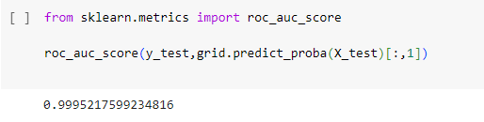

SVM-Grid-Classification:

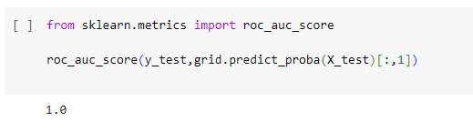

DC-Grid-Classification:

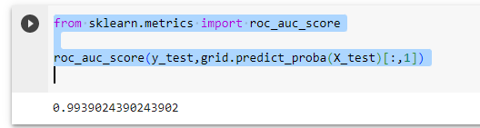

RF-Grid-Classification

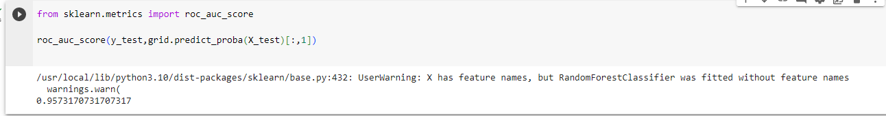

1. My final model is SVM-Grid-Classification because it has a roc_auc_score of 1.